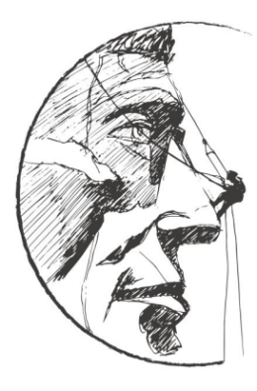
SOUTH DAKOTA ENGINEERING SOCIETY

BLACK HILLS CHAPTER

YOUNG ENGINEER OF THE YEAR AWARD
METHOD OF SELECTION

This award is established to recognize young SDES members who have made outstanding contributions to the engineering profession and their communities during the early years of their careers.

Qualifications/Method of Selection: Any licensed professional engineer (P.E. or E.I.T.), who is an SDES member in good standing who is 34 years of age or younger as of January 1 of the year the award will be presented, is eligible for nomination.

The Awards Committee, which consists of the Black Hills Chapter Awards Committee Chairperson and two Black Hills Chapter Representatives, makes the selection of the recipient based on the following criteria (similar to NSPE’s guidelines):

- Education and collegiate achievements 12%
- Professional society activities 15%
- Technical society activities 12%
- Civic and humanitarian activities 12%
- Continuing competence 12%
- Engineering achievement 25%
- Professional experience 12%

Presentation: The award will be presented at the SDES Engineer’s Week Luncheon and Awards Gala on February 24, 2021.

Nomination Format: Nominations must be made on the prescribed form. The form should be typed. Any supporting data should include the name of the nominee with the section letter and title it supports (up to a maximum of 5 pages). The form must be signed and dated by the candidate, as well as the chapter representative.

Deadline: Nominations are due at the email below by February 5, 2021.

Anne Winckel – anne.winckel@respec.com
SOUTH DAKOTA ENGINEERING SOCIETY

BLACK HILLS CHAPTER
YOUNG ENGINEER OF THE YEAR AWARD
ENTRY FORM

(Please type or print legibly in black ink.)

1. SDES Chapter Information
SDES chapter: Black Hills Chapter
Name of chapter representative: Anne Winckel
Signature of chapter representative
Date:
Address: 3824 Jet Drive
City: Rapid City State: SD Zip Code: 57703
Daytime phone: 605-394-6491 FAX: 605-394-6456
E-mail Address: anne.winckel@respec.com
2. Candidate Information
Name of candidate:
Date of Birth:
Title (indicate if candidate is a P.E.):
Firm/Agency:
Address:
City: State: Zip Code:
Daytime phone: FAX:
E-mail Address:
Candidate’s signature: Date:
3. Attach the following as the basis for nomination of the candidate:
- Education and Collegiate Achievements
Include undergraduate and advanced degrees (give date, major, institution and GPA for each), honorary societies (give society and office held), scholastic awards, organizations (give name of organization and office held) and other activities;

- Professional Society Activities
List offices held, committee assignments and awards at national, state and chapter levels;

- Technical Society Activities
List offices held and committee assignments;

- Civic and Humanitarian Activities
List offices held and committee assignments;

- Continuing Competence
List graduate studies (give course and date), short courses and seminars, and papers published (give article, journal and date);

- Engineering Achievements
Include current position (title, company or institution), responsibilities (number of subordinates, annual budget), accountability (position, function, nature of challenge), patents applied for and awards; and

- Professional Experience
Include dates of employment, employer and description of duties.

4. List Addresses of Local Newspapers and Other Publications
(For publicity purposes. Attach a separate sheet if needed.)

5. Entry Checklist
___ Completed Entry Form
___ Candidate Information (5 page max.)

6. Send Entries to: (Deadline for submittal is February 5, 2021)
Anne Winckel – anne.winckel@respec.com

